# Maximum clique

## Project structure

### MaximumClique

* + 1. Program – class creates EXCEL files for algorithms comparison. Not done properly, excel must be then manually modified to show graphs instead of data.
    2. GraphWorker – reading DIMACS graphs, generating new graphs

### MaximumClique.Algorithms

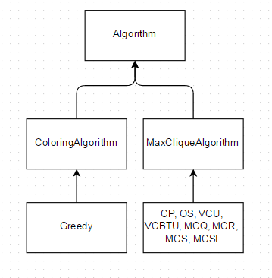

Figure Algorithms inheritance

### MaximumClique.Test

– testing framework NUnit

* + 1. MaximumCliqueBaseTest – Path property determines location of test cases.

Extension property shows files with what extension to run (.clq for max clique tests and .col for coloring).

These are DIMACS graphs. Folder with maxClique dimacs graphs contains answers files (e.g. easy2Answers.txt). Answers file shows what tests to run and max clique for these graphs.

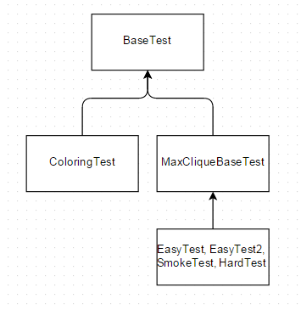

Figure Test classes inheritance

## Problems

### MCSI ILS implementation

### MSC, MSCI PermuteVertices problem

According to Tomita algorithm permute vertices is done after graph is already colored. These colors are used in bound function. If vertices are permuted all color numbers become invalid.